Sheffield Village
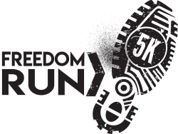
5K Freedom Run
1 Mile Walk
Saturday,
August 21, 2021
Race Starts & Finishes:
Brookside High School Track 1812 Harris Rd. Sheffield Village OH 44054
Race goes to The Nature Center on Colorado and through LC Metro Parks!

8:00am – Race Registration
Kid’s Run!! $5
Immediately following 5K Race
All participants will receive a
Free finishers medal!
Ages 12 & Under

8:40am – Opening Ceremony
9:00am – 5K Race Start
9:01am – 1 Mile Walk Start
9:45am – Award Ceremony

Pulled Pork, French Fries and Cole Slaw will be provided for all participants!
Food provided by:
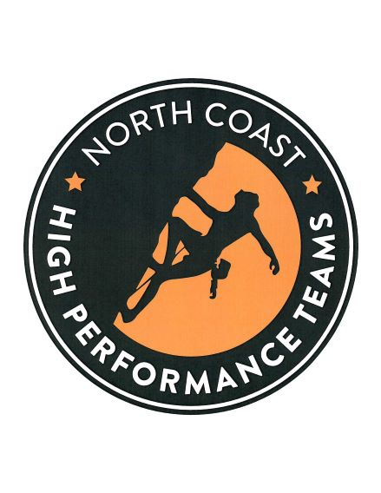
All proceeds to benefit:
BHS Robotics and the
Athletic Boosters

Overall male & female winners receive a $100 Gift Certificate to the Backpackers Shop!

Awards will be given to the top 3 men & 3 women in all age groups:
13 & under, 14-16, 17-19, 20-29, 30-39, 40-49, 50-59, 60-69, 70 & over

Pre-registered participants will receive a free t-shirt and goody bag!

Pre-registration $25 Day of race $30

REGISTER online by Friday, August 20 at 9am at:
www.sheffieldvillage.com or www.TheRuniversity.com

